Derrick Fox

CS 136

June 13, 2014

Week 3 / Chapter 3

p. 133 -134

Week 3 / Chapter 3

1. Create a table listing all tasks separately, with their duration.

|  |  |  |  |
| --- | --- | --- | --- |
| TASK | DESCRIPTION | DURATION (DAYS) | PREDECESSOR TASKS |
| 1 | Meet with center managers | 10 | - |
| 2 | Conduct interviews | 8 | 1 |
| 3 | Observe business operations | 7 | 2 |
| 4 | Review company records | 2 | 2 |
| 5 | Analyze BumbleBee Accounting software | 3 | 3, 4 |
| 6 | Study a sample of sales and billing transactions | 1 | 3, 4 |

2. Identify all dependent tasks, and indicate what predecessor tasks are required.

Every task in our project is dependent on its predeceasing task, expect for the first one. So, the first dependent task is conducting interviews because it is dependent on meeting with the managers first. Both the records review and the observation of the business practices are dependent tasks because they are both dependent on the conducting of interviews. And the software analysis and study sample are both dependent on both the review of the company records and the observation of business practices.

The predeceasing tasks are 1 to 4. The fifth and sixth tasks are not predeceasing tasks because on successive tasks are dependent on them.

3. Construct a PERT/CPM chart similar to the one in Figure 3-27 on page 117. If you have access to Microsoft Project or other project management software, you can use it to help you create the chart.

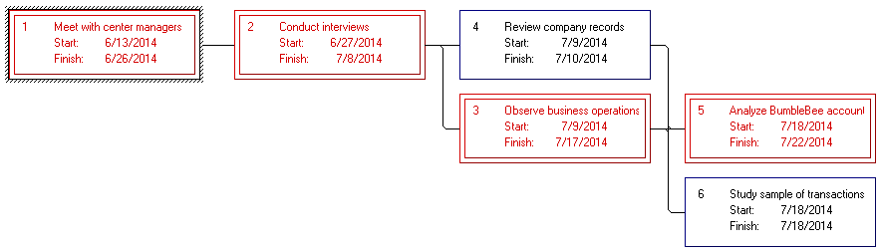

4. Determine the overall duration of the project, and identify the critical path.

The Gantt Chart illustrated above in Question 3 depicts the critical path in red. The critical path is as follows: First, meet with the center managers. Second, conduct interviews. Third, observe business operations. And finally, analyze the BumbleBee accounting software. The last two tasks are included in the critical path as opposed to their concurrent tasks because their durations are longer. The total duration of the project is 36 days.